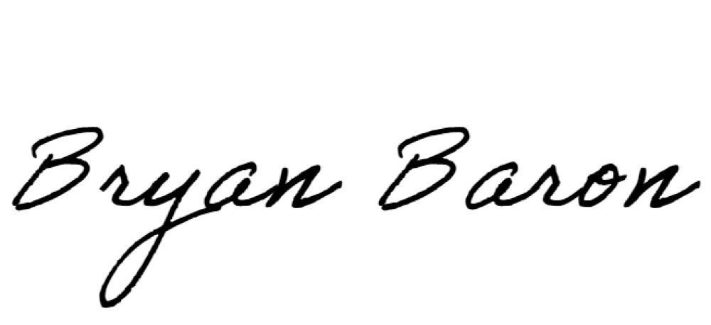
WEBER COUNTY ORDINANCE COVER SHEET

Type of ordinance: □ New X Amendment
Requester: X County department or office: Weber County Sheriff’s Office
□ Other: (name of individual or organization) Contact person (if not requester): Lt. Mark Horton
Phone number: 801778-6914 Email: mhorton@co.weber.ut.us _
Summary and purpose of proposed ordinance (be specific):
County Commissioner Preliminary Approval
Commissioner signature: Date:
County department or office assigned as originating department:
County Attorney’s Office Review
Initial review: | - Approved (no legal concerns)  - Not recommended (see below for unresolved legal concerns)
Signature: Date:

Unresolved legal concerns or other comments:
Second review (if applicable): □ Approved □ Still not recommended due to legal concerns Signature: Date:
Clerk’s Office Review
Initial review: | - Approved  - Not recommended (see below for unresolved concerns)
Signature: Date: Unresolved concerns or other comments:
Second review (if applicable): □ Approved □ Still not recommended due to concerns Signature: Date:
Review by Other Entity
□ Not required □ Reviewed and approved Entity:
County Commission
First Reading  Date: Votes  Jenkins  Froerer Harvey |  | - Approved to be moved to second reading  - Originating department to make changes and submit for second reading  - Final approval given (no second reading necessary)  - Rejected  - Other:
Second Reading Date: Votes  Jenkins Froerer  Harvey |  | - Approved as presented  - Approved with changes  - Rejected  - Other:
Comments (e.g., changes ordered by Commission):
Revised Nov. 2019

